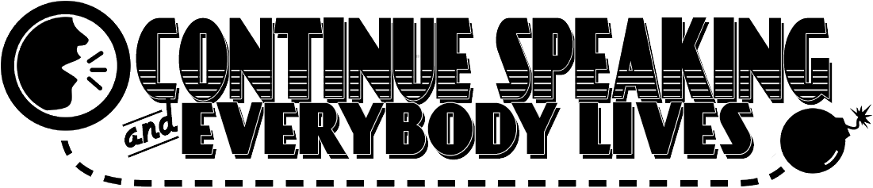
Created by
Ethan Dunning, Zachary Nalepa, Matthew Mahan

Category of Use: Gaming.

Mission Brief:
There is an active bomb that’s been collected by local law enforcements, but the bomb-defusal experts can’t make it in time. Instead, the player will communicate with the defusal experts to identify parts of the bomb and how to defuse it before it explodes and takes the building with it.
Each part of the bomb is a different puzzle that needs to be solved before it is safe. All instructions are given through the defusal expert. Neither player is allowed to look at the other’s materials.

